Social Posts- Coronavirus
For all open offices – even those with drop off only service
As we continue to monitor news and information surrounding the coronavirus, our highest priority remains supporting the patients and staff of <insert business name>. Our thoughts are with all those impacted, as well as those caring for others. Please give us a call if you have any questions or concerns with your hearing!

Reduction in Hours
We are here! Our office will remain open to serve our loyal patients and their needs. Our reduced office hours are now <insert days and times>. The adjusted hours will allow us to schedule appointments for patients most in need of immediate care. We appreciate your understanding and look forward to seeing you very soon.

Top priorities
Your health and safety are our top priority. We closely follow local health and safety guidelines to ensure that every protocol is followed to maintain a safe and clean facility for our patients and staff. If you need to be seen for hearing concerns or hearing aid repairs, please call or email our office to determine how we may quickly and safely assist you!

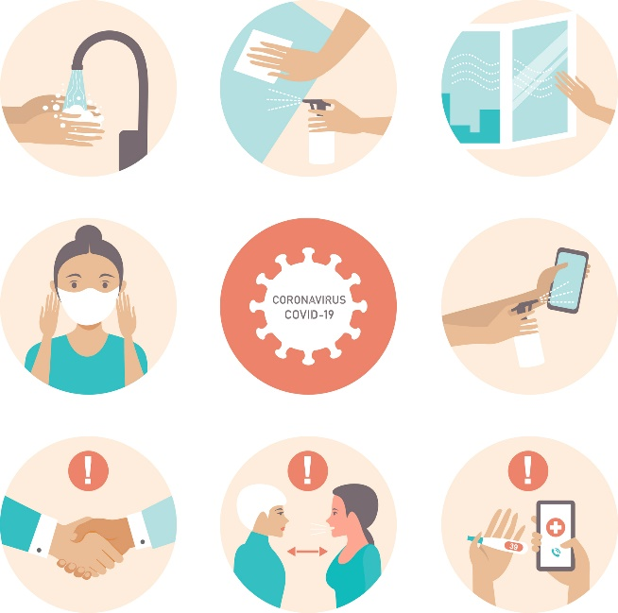

Contact office with hearing questions
Do you currently have hearing concerns? Our office hours are limited during the coronavirus outbreak but we are still here to help. If you have any questions about hearing aids, adjustments, cleanings or anything hearing related, please do not hesitate to call or email the office.
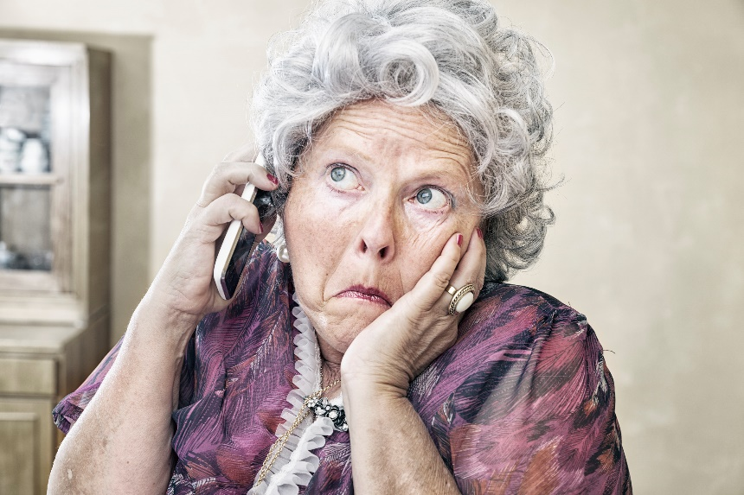

Appointments Only
Do you currently have hearing concerns? During the coronavirus outbreak, our adjusted office hours allow us to schedule appointments for patients most in need of immediate care. If you feel that you may need to be seen for hearing concerns or hearing aid repairs, please call or email our office to determine how we may quickly and safely assist you.
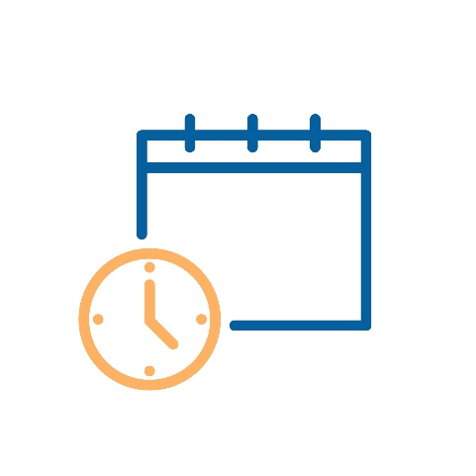

Office Closed
Our office is temporarily closed beginning (date). We’re doing our part to help prevent the spread of coronavirus in our community and protect those most at risk. We will have drop off/pick up service for repairs. Please contact the office for more information. Thank you for understanding and please stay safe!
